BIG DATA LAB

Name:S.L.A.Laisha

USN:1NT19IS147

SEC:C1

Date: 26-04-2022

The values inserted in database:

> db.Details.find()

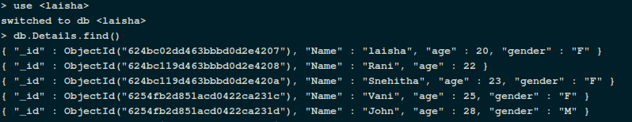

Creating Aggerate pipeline

**Count:**

Count the number of students with age :23

> db.Details.aggregate([{$match:{age:23}},{$count:"Number of students with age :23"}])



**Sum**

Sum of ages of female

> db.Details.aggregate([{$match:{gender: "F"}},{$group:{_id : null,sum :{$sum:"$age"}}}])

Sum of ages of male

> db.Details.aggregate([{$match:{gender: "M"}},{$group:{_id : null,sum: {$sum: "$age" }}}])

Sum of all the ages

> db.Details.aggregate([{$match:{}},{$group:{_id : null,sum:{$sum:"$age"}}}])

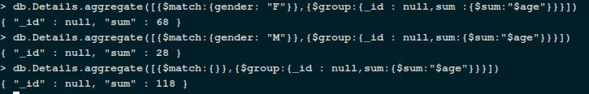

**Average**

Average of all the ages

> db.Details.aggregate([{$match:{}},{$group:{_id : null,avg:{$avg:"$age"}}}])



**Max &Min**

Find the maximum age among all

> db.Details.aggregate([{$group:{_id : "age",aggregate_age:{$min:"$age"}}}])

Find the minimum age among all

> db.Details.aggregate([{$group:{_id : "age",aggregate_age:{$max:"$age"}}}])

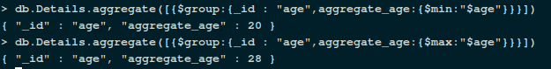

**First & Last values**

Find the first name in database

> db.Details.aggregate([{$group:{_id: "Name" ,aggregate_Name:{$first:"$Name"}}}])

Find the last name in database

> db.Details.aggregate([{$group:{_id: "Name" ,aggregate_Name:{$last:"$Name"}}}])

